**Documentation for HAproxy and Nginx**

**HAProxy:**

(High Availability Proxy) is an open-source load-balancer which can load balance any TCP service. **HAProxy** is a free, very fast and reliable solution that offers load-balancing, high-availability, and proxying for TCP and HTTP-based applications.

Prerequisite:

Take 3 machines

1. Load Balancer
2. Client 1 (with the service to be balanced Eg: Httpd)
3. Client 2 (with the service to be balanced Eg: Httpd)

**Installation :**

yum -y install haproxy

Take a backup of the configuration file.

cd /etc/haproxy/(go to this directory)

mv haproxy.cfg haproxy.cfg.org(backup the file)

create a file

**vi haproxy.cfg** (add the below lines in to the file)

#---------------------------------------------------------------------

# Global settings

#---------------------------------------------------------------------

global

log 127.0.0.1 local2 #Log configuration

chroot /var/lib/haproxy

pidfile /var/run/haproxy.pid

maxconn 4000

user haproxy #Haproxy running under user and group "haproxy"

group haproxy

daemon

# turn on stats unix socket

stats socket /var/lib/haproxy/stats

#---------------------------------------------------------------------

# common defaults that all the 'listen' and 'backend' sections will

# use if not designated in their block

#---------------------------------------------------------------------

defaults

mode http

log global

option httplog

option dontlognull

option http-server-close

option forwardfor except 127.0.0.0/8

option redispatch

retries 3

timeout http-request 10s

timeout queue 1m

timeout connect 10s

timeout client 1m

timeout server 1m

timeout http-keep-alive 10s

timeout check 10s

maxconn 3000

#---------------------------------------------------------------------

#HAProxy Monitoring Config

#---------------------------------------------------------------------

listen haproxy3-monitoring *:8080 #Haproxy Monitoring run on port 8080

mode http

option forwardfor

option httpclose

stats enable

stats show-legends

stats refresh 5s

stats uri /stats #URL for HAProxy monitoring

stats realm Haproxy\ Statistics

stats auth admin:admin@123 #User and Password for login to the monitoring dashboard

stats admin if TRUE

default_backend app-main #This is optionally for monitoring backend

#---------------------------------------------------------------------

# FrontEnd Configuration

#---------------------------------------------------------------------

frontend main

bind *:80

option http-server-close

option forwardfor

default_backend app-main

#---------------------------------------------------------------------

# BackEnd roundrobin as balance algorithm

#---------------------------------------------------------------------

backend app-main

balance roundrobin #Balance algorithm

option httpchk HEAD / HTTP/1.1\r\nHost:\ localhost #Check the server application is up and healty - 200 status code

server host2 192.168.236.136:80 check #httpd server1

server host3 192.168.236.135:80 check #httpd server2

We will configure the rsyslog daemon to log the HAProxy statistics. Edit the rsyslog.conf file to enable the UDP port 514 to be used by rsyslog.

**vi /etc/rsyslog.conf**

**Uncomment** this line to enable the UDP connection:

**$ModLoad imudp**

**$UDPServerRun 514**

Then create new haproxy configuration file for rsyslog:

cd /etc/rsyslog.d/

vi **haproxy.conf**

(add below lines)

local2.=info /var/log/haproxy-access.log #For Access Log

local2.notice /var/log/haproxy-info.log #For Service Info - Backend, loadbalancer

Restart the service

systemctl restart rsyslog

Then stop the httpd service in the machine

Also stop all the services that are running on ports 80 and 8080

To check use the command

lsof –i :8080

lsof –i :80

Start the haproxy service :

systemctl start haproxy

systemctl enable haproxy

To check give the ipaddress of the haproxy machine you can easily view the load balancing happenings.

To check in the terminal use the command

Curl 192.168.236.134(ipaddress of haproxy)

Go to the browser type the ip address of the machine

192.168.236.134/stats

Enter user name (admin) and password (admin@123).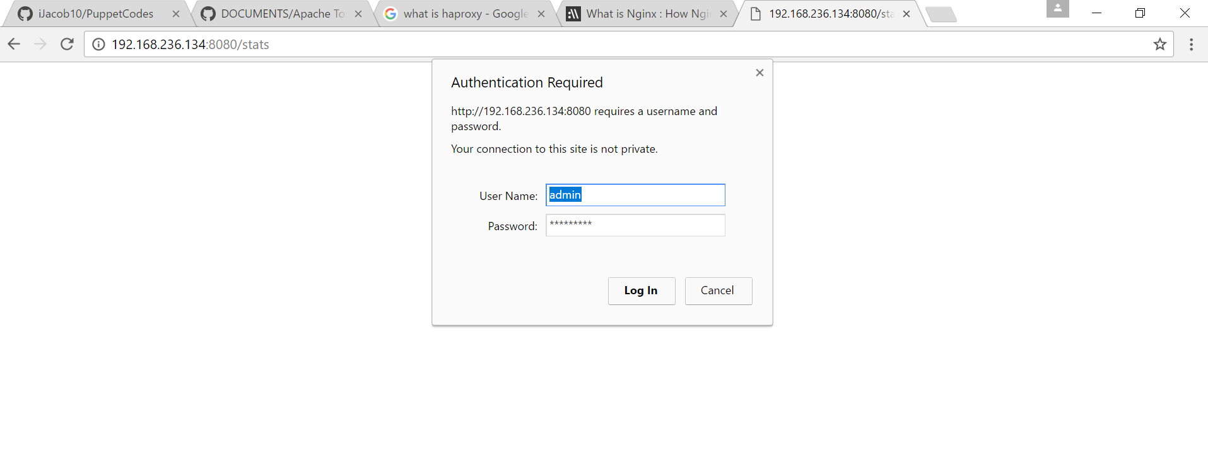

Now we can view the monitoring page for haproxy.

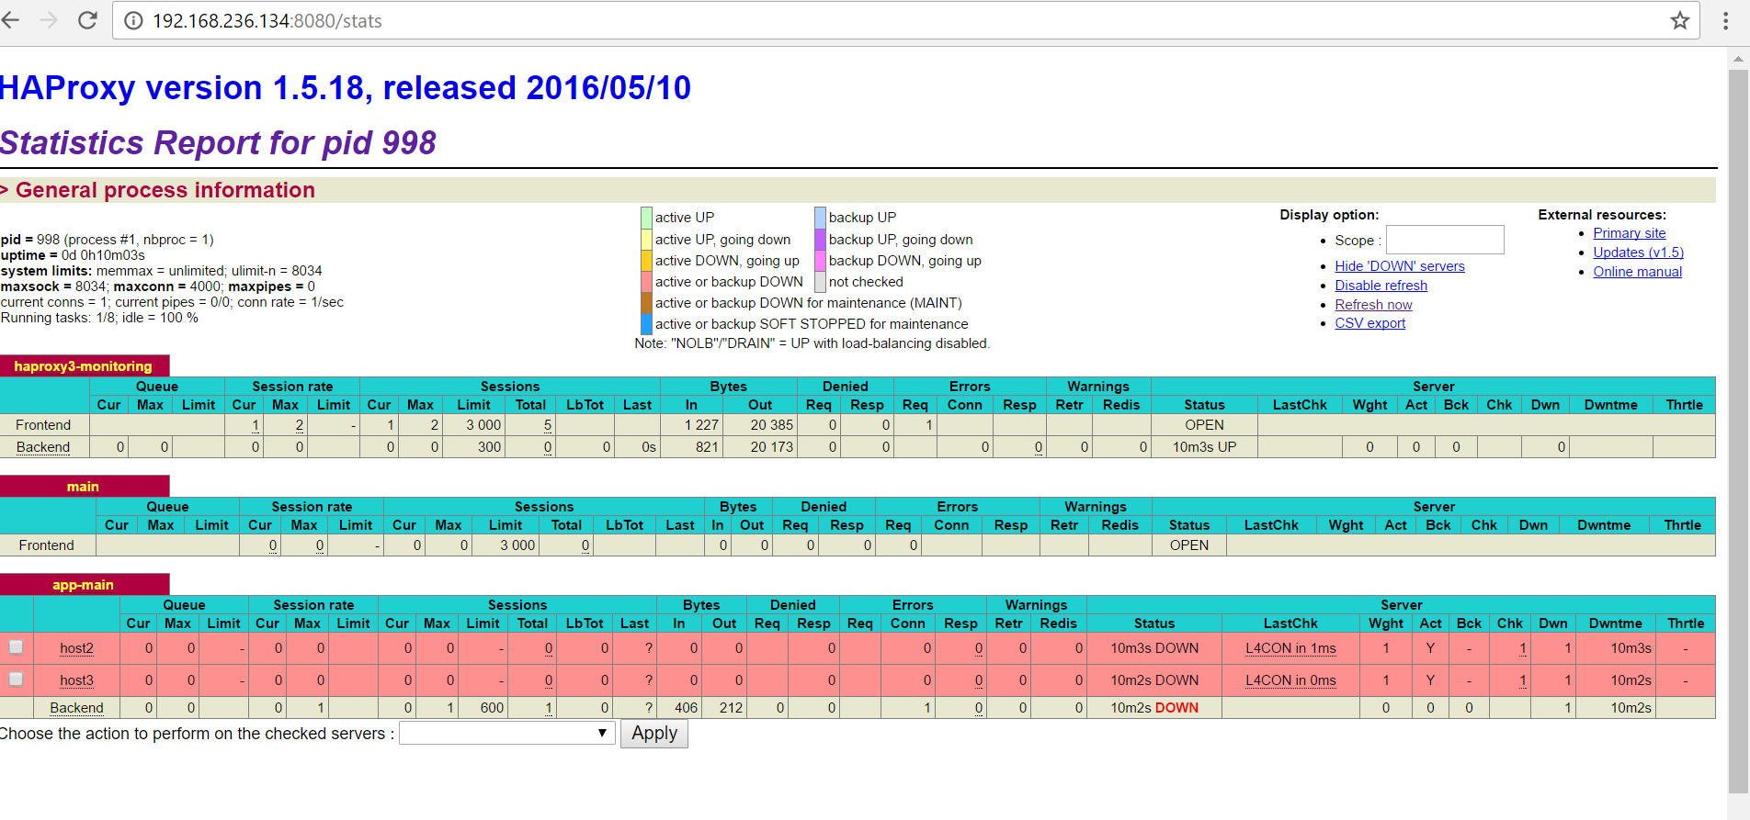

**What is Nginx :**

NGINX (Pronounced as Engine-X) is an open source, lightweight, high-performance web server or proxy server. Nginx used as reverse proxy server for HTTP, HTTPS, SMTP, IMAP, POP3 protocols, on the other hand, it is also used for servers load balancing and HTTP Cache. Nginx accelerates content and application delivery, improves security, facilitates availability and scalability for the busiest websites on the Internet.

Httpd service can run in two mps (Multiple process Management)

1. Prefork( It will create a process for every request)
2. Worker (It will create a process for the first request and other request will be processed by the same PID(process id).

**Installing :**

First stop the haproxy service.

Yum install nginx.

If any error occur

**Yum install epel-release**

**Cd /etc/nginx**

Take a backup of the configuration file

**mv nginx.conf nginx.conf.org**

Create a configuration file:

**Vi nginx.conf**

(add the following Lines)

user nobody;

worker_processes 1;

events {

worker_connections 1024;

}

http {

upstream servers {

server 192.168.236.135;

server 192.168.236.136;

}

server {

listen 80;

location /

{

proxy_pass http://servers;

}

}

}

To check give the ip address of the nginx machine you can easily view the load balancing happenings.

To check in the terminal use the command

Curl 192.168.236.134(ip address of nginx)